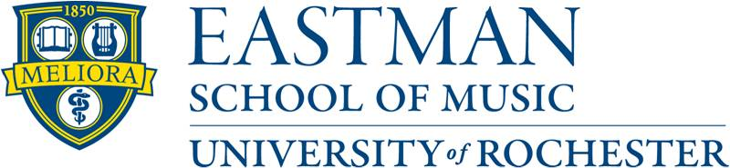
Spring 2023 Course Registration Information
______________________________________________________________________________
Spring 2023 Course Schedule
- Please login to UR Student and use the N1201 – Find Course Section Report –
Select Spring 2023 Eastman for the Academic Period.
The Spring 2023 course sections will be live on October 31, 2022
- Please make sure you check your holds in UR Student. Certain holds will not allow you to register for courses until they are resolved. If you are unsure about your holds, please contact the Registrar’s Office as soon as possible so we can advise you on how to clear your hold(s).
- For more information on UR Student please click on this link: UR Student

On-line Registration Link
Please login to UR Student to register for course sections: UR Student Registration Link
Registration Dates for Spring 2023
Online Registration begins at 8:00 am each morning
Spring 2023 Registration Timeline
• Monday, November 14, 2022 – Graduate Students, Dual Degree, Seniors
• Tuesday, November 15, 2022 – Juniors
• Wednesday, November 16, 2022 – Sophomores
• Thursday, November 17, 2022 – First-Year Students

Registration Deadlines
- Please refer to the Spring 2023 Academic Calendar for registration dates: 2022-2023 ESM Academic Calendar
- Students will be charged a $250 late registration fee if they have not registered by January 22, 2023
- For other important deadlines go to: Registrar Policy - Academic Handbook

Advisor Approval is required for BM Music Education Majors
Undergraduate Music Education majors are required to obtain permission from their Music Education academic advisor to register for Spring 2023 classes. Advisors can grant permission by logging into UR student to remove the advisor hold. Music Education students will not be able to register in UR Student until the advising hold is lifted.

Red Line Bus Transportation
Registering for courses at the River Campus? Make sure Red Line Shuttle Bus times work for you. See the schedule at: University Shuttles

Fall 2022 Final Examination Schedule
The final examination schedule is posted on the Registrar’s web site: Final Exam Schedule

May 2023 Degree Applications
- Students who plan to participate in the May 2023 Commencement Ceremonies are required to submit a Degree Application by January 31, 2023.
- Applications are available on the Registrar's website: Degree Application
- If we do not receive a degree application by January 31, 2023, your name may not appear in the printed commencement/degree program and your name will appear on your diploma as we currently have it listed in UR Student.
- Undergraduate students who complete their degrees in May, August, or December 2023 are eligible to participate in the May 2023 Commencement Ceremony.
- Graduate students who complete their degree in August, October or December 2022, March or May 2023 are eligible to participate in the May 2023 Commencement Ceremony.

Eastman Academic Policy Handbook
It is the responsibility of the individual student to familiarize himself or herself with the announcements and regulations of the University published in official School publications such as the Academic Policy Handbook. The Eastman School Dean's Office and Registrar's Office also issue updated information throughout the year. While every effort is made to ensure the accuracy and timeliness of the information contained in publications, the University cannot guarantee its accuracy due to changes in announcements, teaching and administrative staff, and curricula and courses that may occur after publication date. See the following site for a full description of the Eastman School of Music Academic Policy: Registrar Policy - Academic Handbook

