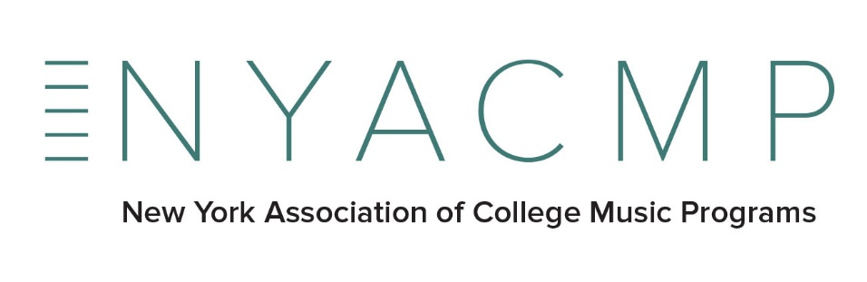
………………………………………………………………………………………………

PLEASE PRINT OR TYPE CLEARLY

Please return a copy of this bottom portion with your payment (or without, if payment will arrive under separate cover) so that we may keep our mailing list current.

Academic Department _______________________________________________________________

Member College_____________________________________________________________________

Address____________________________________________________________________________

City_________________________State__________ZIP_____________________________________

Name and Title (Chair, Dean, Director, Prof, etc.) of your institution’s designated representative to NYACMP.

Name_______________________________ Title__________________________________________

Office Phone_____________________________

E-Mail Address______________________________________

Please send check to
David Heuser, NYACMP Secretary-Treasurer
c/o Crane School of Music
SUNY Potsdam
44 Pierrepont Ave.
Potsdam NY 13676

Please make checks payable to NYACMP.
$50.00 per institution
NYACMP is a 501 (c) (3) organization, EIN 81-5420035

If you have any questions or comments please contact David Heuser at heuserdd@potsdam.edu.

